(2 Point) Design and code a class named Boat that holds information of a Boat.

Teacher
-name:String
-price:double
+Boat ()
+Boat (name:String,price:double)
+getName():String
+getPrice():double
+setPrice(salary:double):void

1. getName(): String – return a name of the Boat where every letters are in lowercase.
2. getPrice (): double – return a price of the Boat
3. setPrice (salary:double): void – set current price of the Boat is to a given price.

The program output might look something like:

No of test case | Correct output
1 | 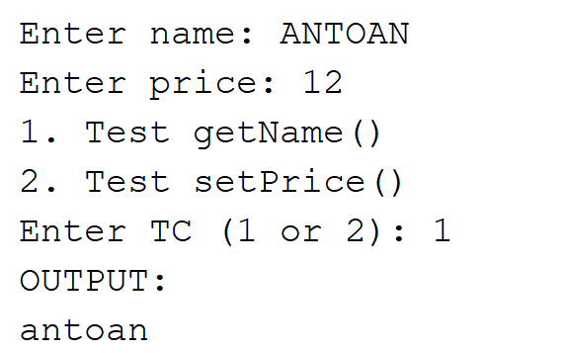
2 | 